* Dart Programming: Data Types:
  + String
  + Number:
  + List: Multiple data type come
    - List = [1,2,3,’hello’]
    - List<string> = [’only string’]
    - List<int> = [1,2,3]
    - List.of(‘convert to list type casting’)
* Int: without decimal point
  + - Double: with decimal point
    - Num: can hold both integer and floating-point numbers
  + Bool: represents a Boolean value (true or false)

Conditional Statements:

* + AND: &&
  + OR: ||
  + NOT Equal: !
* GitHub: Git: Is a command-line interface for version control. After Downloading Git, we can use its interface gitbash or the command prompt (cmd). Git configuration commands:
  + git config --global user.name "username"
  + git config --global user.email "Email"

Common Git Commands:

* + git status
  + git init
  + git add . OR git add filename
  + git commit -m "Add a message describing the changes"

Pushing to GitHub Repository:

* + git remote add origin "Link" (Sets the address of the repository)
  + git push -u origin master (Pushes the code to the master branch of the repository)

Project Update:

* + Green: Nothing to upload (no changes)
  + White: Everything is fine (changes committed)
  + Yellow: Changes are pending (need to be committed)
  + git add .
  + git commit -m "Message"

Git Clone: Used to clone or copy a repository from GitHub to the local machine.

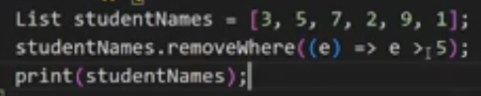 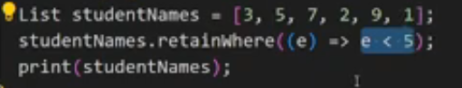

Map:

Similar to python dictionary consist of key and value, key is unique idintifiers

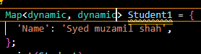

**OOP (Object orentied pragramming )**

 How to Defined Class?

How to make the instance of Class?

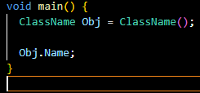

How To import class in one another?

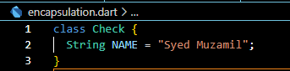

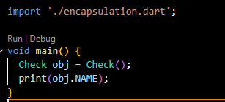

How To Make **parivate variable**

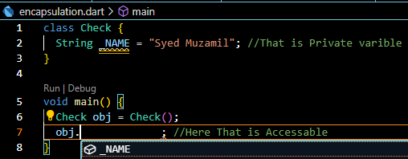

How to make constructor?

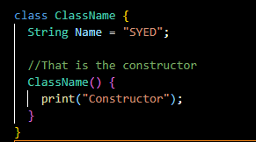

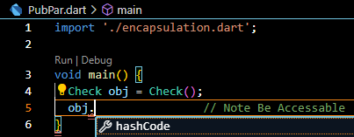

**Note**🡺 the construct name is similar to class name

How to assign value to constructor?

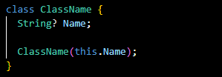

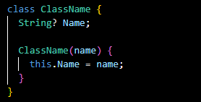OR

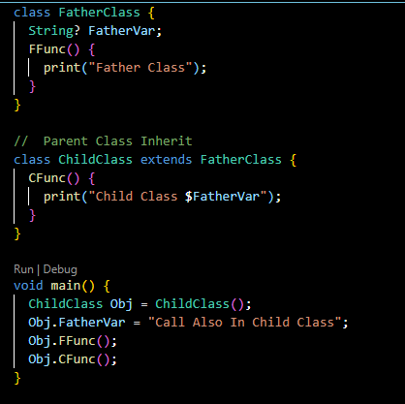**Inheritance**

**Override**

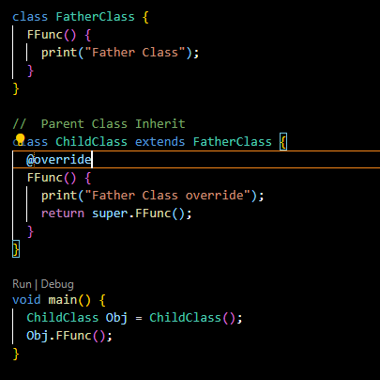

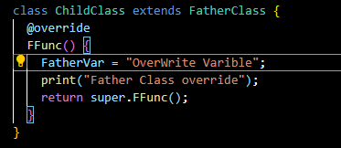If the Vaiable is defined in FatherClass Then we Can be override them is ChildClass Function during overriding function

**OR** We can Also override without function

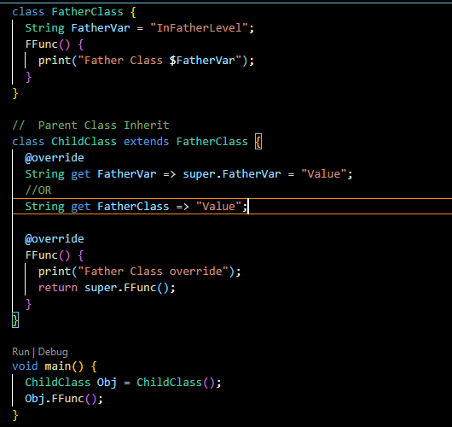

Static Key Word

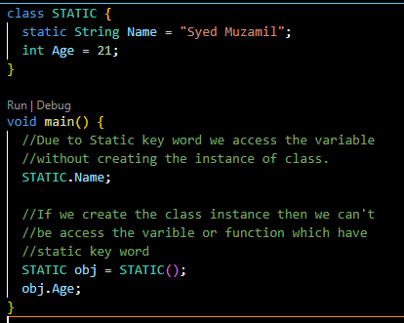

**SOME IMPORTANT POINT**

ExclamationMark (!):

If we use this mark, it indicates that there will not be any null value in the variable.

QuestionMark (?):

If we use this sign, it means that there may be a null value or not.

DoubleQuestionMark (??):

If we use this sign, it means that:

int inner = Name ?? 100;

If null value comes, then the right-side value is stored in the variable.

If not null, then the left-side value is stored in the variable.